1. Introduction to Module 3
▶️ Welcome to Module 3 (0:44)
[MUSIC] Welcome to the third week of the course Statistics for Data Science. In this week, we will cover linear regression, which I'm pretty sure many of you are familiar with. However, linear regression is simplified scenario where we can introduce complex concepts that will be covered later on in more depth.
Before I move on into linear regression though, let me provide you with two videos reviewing linear algebra, which is one of the foundations for linear regression. So let's move on into linear algebra.
2. Linear Algebra Review
▶️ Linear Algebra (7:10)
Before we move on into the topic of linear regression, we're going to review a few concepts of linear algebra. So we denote a matrix A, a matrix with m rows and n columns, where the entries are real numbers. Let's think of a matrix as an array of elements that we can represent as a grid of this form. So in this particular case, we can have an array of numbers with three rows and four columns, and inside these entries, you will have some real numbers, for example, 3, 2.1, and so on and so forth. We can index the elements inside that matrix A using SIP indexes. So we have two ways to write down this indexes, and that we use a bracket, or if it's clear from the context, we can just include the indexes directly attached to the capital letter. So if we want to index, for example, the entry in the first row and the third column, we can use the notation A is to 1, 3, which in this particular case, will take out the value of three of these array. There are some operations that we can do to matrices. One simple operation is the transpose of a matrix, so the transpose of a matrix A is indicated by A super capital T, and what the transposition does, is essentially convert rows into columns. So if you have a matrix A with a particular collection of rows, what A transpose is going to do, is will take these rows and will convert them into columns. So this first row in here, row 1 will become here column 1, the second row 2 will become column 2, and the third row 3 here will become column 3 here. So we're going to get a tall metrics instead of a wide metrics in here. So the number of rows that you have for A, will be equal to the number of columns in A transpose, and the number of columns in A, will be equal to the number of rows in A transpose. A more formal definition is given in this mathematical identity. The transpose operation satisfies certain properties. For example, if you transpose a matrix twice, you get the original matrix. If you transpose the product of two matrices, you get the product of the transpose, but be careful to change the order of these two matrices. So we'll see in a second that, matrix operation is not commutative, so A times B is not the same as B times A. Also, we have that the transpose of a sum is equal to the sum of the transpose. To continue our review of matrix algebra, we can move on to the topic of matrix multiplication. So if we have two matrices, A and B of m rows and n columns and n rows and p columns, we can define the matrix multiplication A times B as a matrix C, with m rows and p columns. So the dimension of these matrices, have to be consistent with each other. For example, if you have a matrix A, which we see before is m times n, and a matrix B, that is n times p, these inner indices must be the same, and the outer indexes are going to be the dimensions that you get for the resulting matrix multiplication. We can define matrix multiplication entry-wise according to this formula, so essentially the ij entry of the matrix C, so they should be capitalized, is going to be equal to a summation of A_ik times B_kj, where k goes from 1 to n. So essentially a way to visualize this is if you have a matrix A and a matrix B, the ij entry of the metric C, that results as the product multiplication of these two matrices, can be computed as follows. So you can take the ith row of A, the jth column of B, and then you multiply the first element in this row times the first element in this column plus the second element in this row times the second element of this column, dot, dot, dot times the last element of this row, times the last element of this column, and this is what is indicated in this formula. In this case, we assume that the number of columns of this matrix is equal to n, that should be equal to the number of rows in this other matrix. Matrix multiplication has some properties. For example, matrix multiplication is associative, meaning if you have AB times C, is equal to A times B times C. So notice that the order of A, B, and C are not changed, the only thing that we change is how we associate matrices using these parenthesis. We also have that the matrix multiplication is distributed, meaning if we have A times B plus C, we can distribute the multiplication as A times B plus A times C, which is what we're obtaining here. Again, the order of the matrices must be respected, meaning you cannot change A times B by B times A, and you cannot change A times C, by C times A. A has to be in front of these matrices. Finally, we also have that the matrix multiplication is not commutative. So this is a source of a lot of confusion for many students. In particular, A times B is different than B times A, and this is why in the previous properties I have explicitly remarked the fact that the matrix multiplication has to be written in the exact order that is indicated in the formulas. We can also define what's called an identity matrix, so we denote an n-by-n identity matrix by capital I_n. This is a square matrix, meaning the number of rows is equal to the number of columns, and the definition is very simple. Essentially, we're going to have an n-by-n array, and the diagonal elements of this array are all going to be equal to one, and the off-diagonal elements are going to be all equal to zero. So you will fill the rest of this matrix with zero elements. So you can easily prove that if you take a matrix A and you multiply it by the identity, what you obtain as a result is exactly the matrix A. This also holds when instead of multiplying after you multiply before.
1 Attempt Quiz: Linear Algebra
進入線性迴歸（Linear Regression）之前，快速複習線性代數（Linear Algebra）的核心基礎。
它主要分為三個部分：矩陣的基本定義與轉置、矩陣乘法及其性質、以及單位矩陣。我們把它們拆解成更好懂的概念和規則：
1. 矩陣的基本定義與轉置 (Matrix & Transpose)
矩陣是什麼？
可以把矩陣（Matrix）想像成一個數字的網格（二維陣列）。
- 我們通常用大寫字母表示（例如 A）。
- 一個 m x n 的矩陣，代表它有 m 個橫列（Rows） 和 n 個直欄（Columns）。
- 索引（Indexing）：要尋找矩陣裡的特定數字，可以用 A_{i,j} 或[A]_{i,j}，其中 i 是第幾列，j 是第幾欄。例如 A_{1,3} 就是第一列第三欄的數字。
矩陣轉置 (Transpose)
轉置就像是把矩陣沿著對角線翻轉，把「橫列」變成「直欄」。符號記作 A^{T}。
- 如果原本的矩陣是「寬的」（列少欄多），轉置後就會變成「高的」（列多欄少）。
- 原本 m x n 的矩陣，轉置後尺寸（Dimension）會變成 n x m。
- 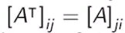
轉置的重要性質：
- 雙重轉置：轉置兩次就會變回原本的自己：(A^{T})^{T} = A
- 相加轉置：相加後轉置，等於各自轉置後相加：(A + B)^{T} = A^{T} + B^{T}
- 相乘轉置（注意！）：相乘後轉置，等於各自轉置後相乘，但順序必須顛倒：
(AB)^{T} = B^{T} A^{T}
2. 矩陣乘法 (Matrix Multiplication)
矩陣乘法不是把對應的位置相乘，它有一套特殊的「內積」規則。
尺寸必須匹配（核心規則）
不是任意兩個矩陣都能相乘。如果 A 乘以 B：
- A 的尺寸：m x n
- B 的尺寸：n x p
- 規則：A 的欄數（後面那個數）必須等於 B 的列數（前面那個數），也就是中間的 n 必須相同。
- 結果：相乘後的新矩陣 C，尺寸會是外側的兩個數：m x p。
怎麼計算？
要得到結果矩陣 C 的第 i 列、第 j 欄的數字（C_{i,j}）：
口訣：左列乘以右欄
拿 A 的第 i 個橫列，和 B 的第 j 個直欄。將它們對應位置的數字依序相乘，最後全部加起來。 數學公式寫作：
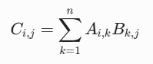
矩陣乘法的重要性質：
- 結合律（對）：(AB)C = A(BC) ── 括號先括誰都一樣，但前後順序不能變。
- 分配律（對）：A(B + C) = AB + AC ── 展開時，A 在左邊就必須保持在左邊。
- 交換律（錯 ❌）： AB != BA
這是學生最常犯錯的地方！矩陣乘法順序絕對不能對調。有時候 AB 可以算，換成 BA 甚至連尺寸都不匹配、根本無法計算。
3. 單位矩陣 (Identity Matrix)
單位矩陣（記作 I 或 I_{n}）在矩陣世界裡的角色，就像是數字世界裡的 「1」。
特徵：
- 它必須是方陣（Square Matrix），也就是列數等於欄數（n x n）。
- 它的主對角線（左上到右下）全部都是 1，其餘的位置全部都是 0。
例如 3 x 3 的單位矩陣：
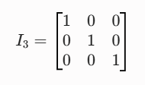
性質：
任何矩陣乘以單位矩陣，都維持原樣不變。這是矩陣乘法中極少數可以交換順序的情況：
AI = IA = A
💡 複習小結（在線性迴歸中的用途）
接下來你學線性迴歸時（例如推導「正則方程 Normal Equation」 θ = (X^{T}X)⁻¹ X^{T}y），會大量把數據排成矩陣 X。到時候你會頻繁用到：
- 用 X^{T} X 來把矩陣變方陣。
- 利用 (AB)^{T} = B^{T} A^{T}來展開公式。
- 利用單位矩陣 I 來處理矩陣的反矩陣（Inverse）。

▶️ Eigenvalues and Eigenvectors (6:13)
Let's introduce a few concepts of vector algebra. We denote by a small bold letter x, a vector with n real entries, essentially an element of R_n. So bold x is going to be an array of elements x_1 to x_n. By convention, the n-dimensional vector x is going to be a matrix with n rows and one column. Essentially n will be a column vector, not a row vector. This is different than this vector in here. We can index elements of the vector x using the notation x_i. So notice that we include a sub-index i and we remove the bold phase. We can also define product of vectors. We have two types of product. The first one is an inner product of two vectors, x and y of the same dimension n. The result of this product is a scalar that is defined below. So we use this notation to indicate the inner product of the two vectors and by definition, this is equal to x transpose y. So notice that x is a column vector. So x, y is going to be a row vector. X_1 to x_ n, y is also a column vector, so it's going to be a vector with elements y_1 to y _n. Now the dimensions of this vector is 1 times n. The dimensions of the second vector is n times 1. So the inner indexes match each other so this is a proper multiplication. The result of this multiplication is a one-by-one matrix, which is nothing by a scalar, a real number. An explicit expression for this matrix multiplication is given in middle formula, but this is nothing but an explicit application of matrix multiplication to the vector case. Also notice, that in the case of the inner product, we can change the order of the vectors. Instead of having x transpose y, we can have y transpose x and applying this formula, we would obtain the same exact value. Therefore, we have that the inner product of two vectors is commutative. We have a second type of vector product called the outer product of two vectors, x and y of the same dimension. In this case, the outer product is defined as x, y transpose. So notice how the transpose symbol, instead of being on the x is on the y. This is a metrics m by n. You can easily convince yourself of this just by looking at the dimensions of x and y. So x is a column vector of dimension n times 1, and y is a row vector of dimension 1 times n. So again, the inner indexes match each other, so this is a proper metrics multiplication. The result of this product is going to be an n-by-n matrix as indicated in here. You can also very easily verify that the ij entry of this n-by-n matrix is going to be equal to xi, the i-th entry of x times yj, the j-th entry of y. Naturally, we also have the product of a matrix and a vector, so we have a matrix of dimension m times n and an n-dimensional vector, then we can define the product a times x. Again, the dimensions should match. We have that a is m by n and x is n by one. Therefore, the inner index mismatch and the resulting product is going to be an m by one vector, which is just an m-dimensional vector. Essentially, y is going to be a vector of dimension m. Again applying the rule of metrics multiplication, the i-th entry of the vector y will be defined by the summation. Finally, we are going to move on to the concept of eigenvalues and eigenvectors. These concepts are related to square matrices. For example, let's consider a metrics n of dimension n by n meaning n rows and n columns. We say that a vector v of dimension n, and noticing here that the entries of this vector can be complex. So this is why I put the fancy C in there. The entries do not have to be real numbers, can be complex numbers. So v is an n dimensional column vector of complex numbers. We say that v is an eigenvector of m if there exist a complex number Lambda called the eigenvalue of v, such that the following equation is satisfied. Essentially, this is called the Eigen equation and reads as follows, so if we're able to find a Lambda and a v such that the multiplication of v with the metrics is equal to the scalar Lambda times a matrix, then these Lambda called a eigenvalue and the associated eigenvector is v. It turns out that for symmetric matrices, which are defined according to this condition, there are n possible choices for the eigenvalues and eigenvectors. In other words, if you look at the Eigen equation, that is not just one solution, but you have n different solutions. So you have n different eigenvalues that can satisfy this equation. For each Eigen value, you will have a corresponding eigenvector. Furthermore, in the case of symmetric matrices, we know that this eigenvalue is a real number. The eigenvector is an n-dimensional vector of real entries. Also the inner products between any pair of eigenvectors is equal to zero. In other words, the eigenvectors are perpendicular to each other.

向量代數（Vector Algebra）以及線性代數中非常經典的特徵值與特徵向量（Eigenvalues & Eigenvectors）。
在機器學習與線性迴歸中，向量通常用來代表「單一筆數據的特徵」或「模型的權重（Weights）」。我們同樣把它拆解成四個核心觀念來理解：
1. 向量的基本定義 (Vector Definition)
慣例：向量預設是「直的」
- 在數學和機器學習裡，如果我們看到一個小寫粗體字（如 x），在沒有特別說明的狀況下，它預設就是一個「欄向量（Column Vector）」。
- 它的尺寸是 n x 1（有 n 個橫列，但只有 1 個直欄）。
- 如果要找裡面的第 i 個元素，我們會去掉粗體，寫成小寫斜體加上下標：x_{i}。
💡 換句話說：如果你想要一個「橫的」行向量（Row Vector，尺寸 1 x n），你就必須對它加上轉置符號，寫成 x^{T}。
2. 兩種向量乘法：內積與外積 (Inner & Outer Product)
假設有兩個相同維度（n x 1）的直向量 x 和 y：
內積 (Inner Product / Dot Product)
- 公式：
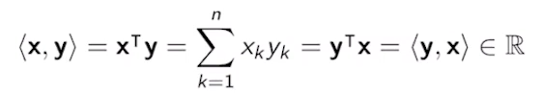
- 尺寸拆解：x^{T}是 1 x n（橫），y 是 n x 1（直）。
中間的 n 匹配，乘出來的結果是一個 1 x 1 的矩陣 ── 也就是一個純量（Scalar，單一實數）。
- 怎麼算：把兩個向量對應位置的數字相乘後全部加起來：
- 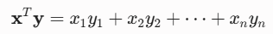
- 特性：內積具有交換律。也就是x^{T} y= y^{T} x，誰放前面算出來的數字都一樣。
外積 (Outer Product)
- 公式：x y^{T} （注意！轉置符號跑到後面的 y 去了）
- 尺寸拆解：x 是 n x 1（直），y^{T} 是 1 x n（橫）。
中間的 1 匹配，乘出來的結果是一個 n x n 的矩陣！
- 怎麼算：結果矩陣中第 i列第 j 欄的元素，就是直接拿 x_i ∙ y_j。
- 特性：外積不具備交換律，xy^{T} ≠ yx^{T}（它們會互為轉置矩陣）。
3. 矩陣與向量的乘法 (Matrix-Vector Multiplication)
這可以看作是矩陣乘法的一種特例。
- 假設矩陣 A 的尺寸是 m x n，向量 x 的尺寸是 n x 1。
- 相乘結果 y=Ax 的尺寸會是 m x 1 的向量。
- 物理意義：這在幾何上代表一種線性變換（Linear Transformation）。矩陣 A 像是一個「加工機器」，你把一個 n 維的向量 x 丟進去，它幫你輸出一個全新維度（m 維）的向量 y。
4. 特徵值與特徵向量 (Eigenvalues & Eigenvectors)
這是最抽象、但也最重要的部分。它只針對方陣（Square Matrix，例如 n x n）討論。
核心幾何意義
一般來說，一個向量 v 乘以一個矩陣 M 之後（得到 Mv），這個向量的長度會變、方向也會旋轉。
但是，如果運氣很好，你找到了一個特殊的向量 v，它乘以 M 之後，方向完全沒有變（或者剛好相反），只有長度被拉長或縮短了！
- 這個被拉長或縮短的倍數，就叫做特徵值（Eigenvalue，記作 λ）。
- 這個方向保持不變的特殊向量，就叫做特徵向量（Eigenvector，記作 v）。
數學公式（特徵方程）寫作：
Mv = λv
對稱矩陣（Symmetric Matrix）的超讚性質
在機器學習中（例如協方差矩陣、線性迴歸的資訊矩陣），我們最常遇到的都是對稱矩陣（也就是滿足 M^{T} = M 的矩陣）。對稱矩陣有三個非常完美的特點：
- 實數解：雖然一般矩陣的特徵值可能是複數（包含虛數 i），但對稱矩陣的特徵值 λ 絕對是實數，特徵向量的元素也都是實數。
- 解的數量：一個 n x n 的對稱矩陣，剛好可以找到 n 組互相對應的特徵值與特徵向量。
- 彼此垂直（正交 Orthogonal）：任意兩組不同的特徵向量，它們的內積等於 0。這意味著這些特徵向量在幾何空間中全部都是互相垂直的！
💡 複習小結（在線性迴歸中的用途）
- 為什麼要學這個？在進階的線性迴歸分析中（例如多重共線性診斷，或者脊迴歸 Ridge Regression），我們會去計算資料矩陣 X^{T} X 的特徵值。
- 如果發現某個特徵值接近 0，就代表數據中存在嚴重的共線問題（特徵之間高度重複）。



3. Linear Regression and Statistics
▶️ Linear Regression (9:22)
Welcome back. In this set of slides, we're going to cover the topic of linear regression. In particular, we're going to consider the additive model that we show below. According to this additive model, the output variable y is going to be generated as a function that depends on a vector of inputs x, and a collection of parameters Beta plus some measurement noise. So the vector bold x contains the variables x_1, x_2, up to x_p. These are p random variables representing the p inputs of our problem, and the vector Beta contain the values Beta_0, Beta_1, Beta_2, up to Beta_p. These are deterministic but unknown coefficients. So you can read the details below. Essentially, the random vector x is going to be drawn according to a marginal distribution effects. The coefficients Beta_0, Beta_1, Beta_p, as I mentioned before, are deterministic but unknown coefficients, and the measurement noise Epsilon follows a PDF f Epsilon. Notice that given the marginal of x and the equation of the additive model, we can compute a joint PDF, f of x, y. In this set up, the linear regression problem can state it as follows. We are going to have a training data set which we have seen before are collection of n pairs. Each one of these pairs contains a vector of inputs x_i, and a scalar output y_i. We're going to assume that these pairs are drawn independently from a joint distribution, f x, y. This is the joint distribution induced by the additive model. Our problem is then to estimate the value of the unknown coefficients Beta_0 to Beta_p. We will denote our estimations by Beta_0 hat up to Beta_p hat. So in general, these values, the Betas without the hats, are only known by nature. These are the values that nature uses to generate the training data set that we observe. Our estimates based on data will always have a hat on it. So this is a convention that we're going to use throughout the course. Once we have these estimates, we can make predictions about the output variable corresponding to a new input we haven't seen before. So we can call this new input by x. Again, this x will be a vector containing p input variables. We can make predictions about the output that could correspond to that particular input by simply using the function described in the additive model. The only difference is that now instead of Beta, which is something we cannot know, we use Beta-hats, essentially the values of Beta that we estimate from data. The resulting function is going to be a linear combination of inputs weighted by the Beta-hats. Also, by convention, whenever we see Beta-hat without sub-index, what we will refer to is the column vector of Betas. So notice the transposition make that vector into a column. To find the vector of estimated coefficients, Beta-hat from data, meaning the training data set that we're given before, we need to solve the following optimization problem. So in this optimization problem, we need to minimize the summation. This summation contains the square of the difference of two terms. The first term is y_i. These are the outputs in our datasets. The second term, if the evaluation of f of L using the input x_i, and a set of parameters, Theta, this is the prediction of the output corresponding to an input x_i when the parameters Beta are equal to a generic value of Theta. The difference between these two terms is what's called the error or the residual of the i-th data point. We can take this error squared and compute the summation for all data points. This is what's called the residual sum of squares that we will denote by RSS. Now, the whole point of this optimization problem is to find the optimal value of Thetas that will minimize this RSS, and that optimal value will be stored in the vector Beta-hat. So just to avoid any confusion, Theta is a vector of unknown coefficients, in this case are just dummy coefficients that we use to state the optimization problem. Instead of Theta, we could have used any other letter. Using matrix vector notation, we can write the optimization that we saw in the previous slide using the equation below. Essentially, the RSS can be written as the square norm of the difference of two vectors, the vector y, which is nothing but the column vector of outputs, y_1 up to y_n, and the matrix vector product, M_x times Theta, when M_x is defined in this equation here. So you can easily verify that if you multiply the matrix M_x by a vector of parameters Theta, so this is going to be a vector containing parameters Theta_0, Theta_1, up to Theta_p, you are going to obtain an n-dimensional vector. The entries of this vector are going to be the evaluation of the function f_L, evaluated at the first point using the parameters Theta. So essentially a genetic set of parameters, and we can keep going up to the n-th entry, which will be generated using the n-th input vector. Now, if you subtract the vector y minus the vector corresponding to this multiplication, what you are going to obtain is another vector of n-dimensions, where each entry is going to be the difference between y_1 and this term up to y_n, and this term. Now, you can easily check that if you compute the length of that vector and you square it, you're going to get exactly the RSS. This derivation is simply based by the fact that the square of the length of a vector is equal to the sum of the square of the components of this vector. I'm going to leave this as a simple exercise for you. Using optimization tools, we can find an explicit solution to the optimization problem as stated above, and the solution is provided at the bottom of the slides. Essentially, for those of you that have seen linear regression before, this should be familiar. This matrix is called the pseudo-inverse. You can check that the dimensions of all these multiplications are correct. Essentially, the output of those operations will be a vector Beta-hat of the proper dimensions. We can now look at the simple case of a univariate regression. In that case, we are going to have p equal to 1, meaning one single input. Therefore, the vector x becomes a scalar x. This is what we represent in this entry. Essentially, when x_i is a scalar, we can remove the boldface. Then the regression function takes this form formed by a value Beta_0, which is called the intercept, and a value Beta_1 hat, which is called the slope. This slope will be multiplying the input x_1, which is the only input in the system. Using the pseudo-inverse and using simple rules of linear algebra, you can come up to a close form expressions for Beta_1 and Beta_0. These expressions involve two new terms, x-bar and y-bar defined in here. If you look into the equations, this y-bar and x-bar are nothing but the empirical means of the values y_i and x_i correspondingly. In the plot below, we provide a concrete example for a linear regression problem. In the univariate case, we're going to have an input variable x and an output variable y. You see in a linear additive model, we generate a cloud of points plot in there. The gray line that you can see at the bottom of this plot represents the true regression function that nature is using to generate the data. Essentially, Beta_0 and Beta_1 are used to generate that particular gray line. Using the data points and expressions above, we can compute our estimate for the linear regression, which is the blue line that I just mark on the screen, and the red vertical lines correspond to the errors. So at the end of the day, what the RSS is doing is collecting the lengths of all these vertical segments and doing a sum of the squares of those residuals.
1 Attempt Quiz: Linear Regression
正式進入線性迴歸（Linear Regression）的核心理論。它建立了如何用數學（矩陣與向量）來描述資料、定義誤差，並找到最佳預測模型的完整流程。
我們可以把這段內容拆解為四個核心步驟：建立模型、定義誤差（RSS）、矩陣化表達、以及求解與視覺化。
1. 加性模型與資料定義 (The Additive Model)
真實世界中，我們想用一組輸入特徵 x 來預測輸出 y。教授介紹的「Additive Model」公式如下：
- 輸入特徵 x：包含 p 個特徵的隨機向量（例如：預估房價時，包含坪數、房間數、屋齡）。
- 真實參數 β：由「大自然」決定、確定但未知的係數。其中 β0 是截距（Intercept），其餘是權重（Slopes）。
- 雜訊 ε（Epsilon）：測量誤差或無法被特徵解釋的隨機波動。
- 我們的任務：利用成對的訓練資料 ((x1, y1), (x2, y2), …., (xn, yn))，去估算出一組最接近大自然的係數，我們記作 hat{β}（讀作 Beta-hat）。
💡 重要慣例：在統計學中，有戴帽子（hat{}） 代表這是我們「從資料估算出來的估計值」；沒戴帽子（β） 代表大自然真正的完美真實值。
一旦算出了 hat{β}，當來了全新、沒看過的輸入 x 時，我們就能做出預測（Prediction）：
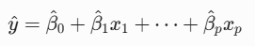

2. 什麼是最佳模型？── 最小化殘差平方和 (RSS)
我們要怎麼知道哪一組 hat{β} 最好？答案是：讓實際觀測值 yi 與 模型預測值 之間的差距愈小愈好。
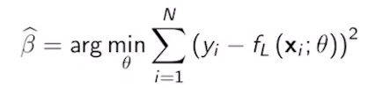
這個差距 (yi - f_L(xi, θ)) 稱為殘差（Residual）或誤差（Error）。把所有資料點的殘差平方後全部加起來，就叫做 殘差平方和（Residual Sum of Squares, RSS）：
線性迴歸的目標，就是找到一組參數 theta，能讓這個 RSS 達到最小值。

3. 轉化為矩陣符號 (Matrix Notation)
如果一筆一筆資料用 Σ（加總符號）來寫，推導公式會非常繁瑣。所以教材內將它轉換成我們上一堂課複習的矩陣與向量形式。
我們可以把所有資料打包：
- y：所有訓練集的輸出，是一個 n x 1 的直向量。
- Mx（通常在機器學習中更常記作設計矩陣 X）：把所有輸入特徵排成一個 n ∙ (p+1)的大矩陣。為了容納截距 β0，第一欄全部填上 1。
這樣一來，所有資料點的預測值就可以簡單寫成矩陣相乘：Mx ∙θ。
而整個 RSS 的優化問題，就可以用向量長度的平方（平方範數，Squared Norm）表達：
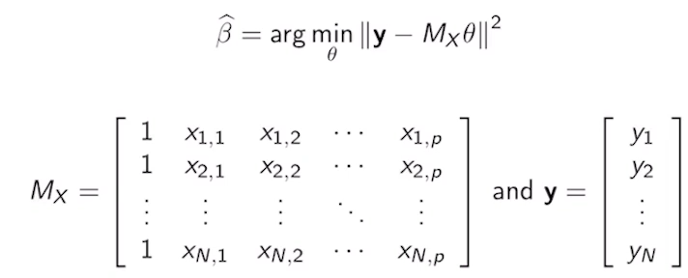
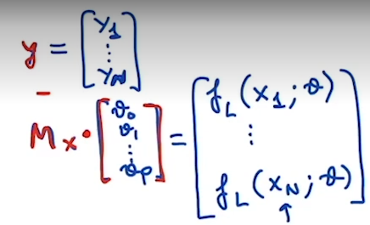

核心解答：虛擬反矩陣 (Pseudo-Inverse)
透過微積分對 theta 微分並令其為 0，可以直接得到這個優化問題的閉式解（Closed-form solution）。這就是著名的正規方程（Normal Equation）：
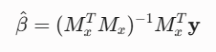
這裡的 $(M_x^T M_x)^{-1} M_x^T$ 就是教材中提到的 偽逆矩陣（Pseudo-inverse）。有了這個公式，只要把資料代入，就能一秒算出最佳的 hat{β}

4. 單變數線性迴歸與幾何視覺化 (Univariate Case)
為了好理解，教材最後降維到 p=1的情況（只有一個輸入特徵 x），這時候模型在二維平面上就是一條直線：y = β0 + β1∙ x
透過前面的偽逆矩陣公式展開，可以得到斜率 hat{β1} 和截距 hat{β0} 的經典統計學公式。這些公式會用到 x 和 y 的樣本平均值（Empirical Means） bar{x} 與 bar{y}
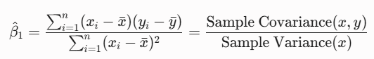
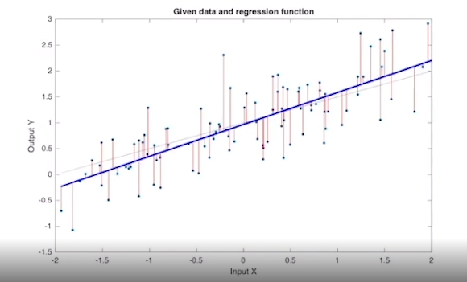
投影片圖片的幾何意義：
- 散點（Cloud of points）：大自然根據真實直線加上隨機雜訊 epsilon產生的真實數據。
- 灰色線（True function）：大自然背後真正的直線（我們實務上永遠看不到）。
- 藍色線（Estimated line）：我們透過上面公式算出來的 hat{β} 直線。這條直線會盡可能穿過這群點的中心。
- 紅色垂直線（Residuals）：每個點到藍色線的垂直距離。藍色線之所以是「最佳」，就是因為它做到了所有紅色線段的平方和（RSS）是所有直線中最小的。

💡 觀念檢查
- 為什麼是垂直距離而不是垂直於直線的距離？ 因為我們的誤差（雜訊 epsilon）是發生在 y軸（輸出端），輸入端 x 假設是精確無誤的。
- 為什麼要平方？ 如果不平方直接相加，正的誤差和負的誤差會互相抵消，我們就無法衡量真正的誤差總量。

推導normal equation:
向量長度平方等於自己與自己內積: ||v||² = v^{T} v
||y - M_{x}∙θ||² = (y - M_{x}∙θ)^{T} (y - M_{x}∙θ)
= (y^{T} - θ^{T}∙M_{x}^{T}) (y - M_{x}∙θ)
= y^{T} y - y^{T} M_{x}∙θ - θ^{T}∙M_{x}^{T} y + θ^{T}∙M_{x}^{T} M_{x}∙θ
注意y^{T} M_{x}∙θ的尺寸是 (1 x n) (n x (p+1)) ((p+1) x 1) = 1 x 1 是一個純量
純量的轉置等於他自己: y^{T} M_{x}∙θ = (y^{T} M_{x}∙θ)^{T} = (M_{x}∙θ)^{T} y = θ^{T}∙M_{x}^{T} y
= y^{T} y - 2 θ^{T}∙M_{x}^{T} y + θ^{T}∙M_{x}^{T} M_{x}∙θ

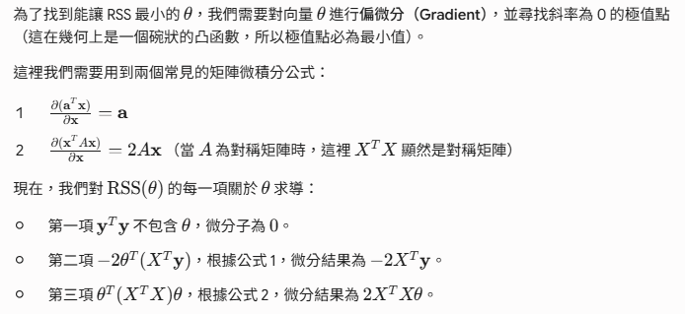
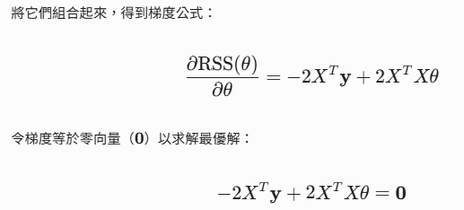
推導單變數的Beta
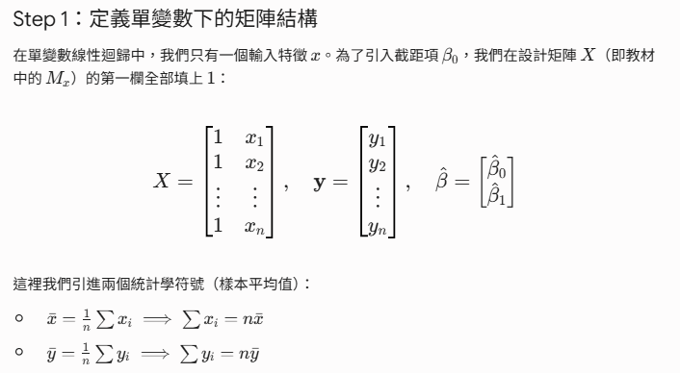
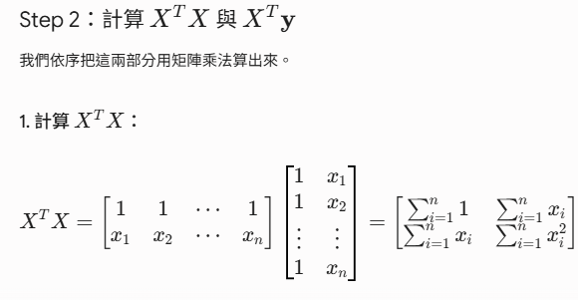
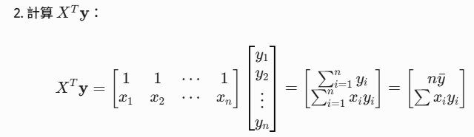
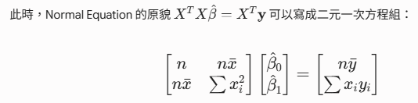
▶️ Coefficient Uncertainty (6:56)
We're going to start this video by assuming that we observed a dataset generated by an additive linear model of the form that you're observing here. This is just a compact form of the additive model that we described in the previous slides. Essentially what we have in here are p-dimensional data points distributed according to a particular marginal distribution. We also have a vector of outputs that can be written as the product of the matrix M_K defined in the previous set of slides times the vector beta plus a vector of measurement noises epsilon. So essentially this vector epsilon is going to contain random variables E_1 to E_N where E_i is distributed according to this particular PDF. You can easily verify that performing this product allows you to generate in one shot all the outputs in the vector y. We saw in the previous set of slides that we can estimate the linear coefficients beta-hat from a dataset using this expression. So essentially the output values are stack together into a vector y and the vector of inputs are also stuck together into a matrix M_X. A very important point to note is that the data points X_i, and Y_i are random, therefore the coefficients beta-hat are random variables themselves. You can convince yourself by looking at the expression of beta-hat, since M_X contain points X_i and the vector y contain the values Y_i, and both X_i and Y_i are random, this expression will result in a random vector. Now since beta i are random variables, we can study their expectations and their variances. In particular, one can analyze the mean, so one can easily prove that the expected value of beta i-hat is exactly equal to beta i, the thing that beta i-hat is trying to estimate. When this happens, we say that the estimator is unbiased. We can also analyze the covariance matrix of the vector beta-hat, assuming that we are given the data matrix M_X, the covariance metrics can be written as we have in the expression at the bottom. Essentially, what do we have in here is the metrics M_X that compiles all the input vectors and sigma-squared which is the variance of the measurement noise. In the following slides, we'll show how the entries of the covariance metrics can be explicitly computed for the case of p equal to 1, meaning when we have one single input. Assuming that we have one input, the linear regression model takes this form. Essentially we only have one intercept, that's the zero-hat and one estimated slope, beta one-hat. Notice that the diagonal elements of the covariance matrix are nothing but the variances of the estimated coefficients. To convince yourself of this fact, remember that if we look at the ij entry of the covariance matrix, this was nothing but the expectation of the variable X_i minus the mean of X_i, so I'm going to call the mean of X_i u_i just for simplicity, times the variable X_j minus the mean of X-j, which I'm going to call Mu_j. Now the diagonal elements of this metric sigma would correspond to points in which these value j is substituted by i. Therefore this term becomes a square, and this is exactly the definition of the variance of X_i. In other words, the ith diagonal element of the covariance matrix sigma is equal to the variance of the ith random variable contained in the ith entry of the random vector X. Using this fact, we can compute the variances of beta one-hat and beta zero-hat given the dataset. These variances take the form in this expressions, which as you can notice, depend on the values of the input entries and the variances of the measurement noise. In this course, we will use SD to denote the standard deviation of a random variable, that's why the variance above can be written as the standard deviation squared of each one of the estimated coefficients. To illustrate the statistical properties of our estimate beta one-hat, let's consider the following numerical example. In this example, we considered an unrealistic but illustrative situation. In particular, we considered 1,000 independent realizations of the training dataset where k will go from 1-1,000. Notice that in practice, this is something that's not typical. In particular, we will have a single realization of the dataset, but for this illustration, we will assume this unrealistic scenario. We'll also assume that each dataset contains n equal 100 samples. In particular, we consider pairs of inputs, outputs from 1-100, where the superscript k represent the particular training dataset that we consider. Now for each training dataset, we're going to compute the corresponding estimates, beta zero-hat and beta one-hat, where again the superscript k goes from 1-1,000 representing the different realizations of the training dataset. After performing this computations, we show in this figure a histogram of the 1,000 realizations of beta one-hat for the 1,000 different values of k. Notice that the histogram is center around 0.5, which is a theoretical value we should expect, since beta-one is equal to 0.5. Also we have that the standard deviation of this bell curve is extremely close to 0.05, which is the theoretical standard deviation, and it's clear from the histogram that the distribution of beta one-hat follows approximately a Gaussian distribution.
1 Attempt Quiz: Coefficient Uncertainty

這段教材帶你進入線性迴歸的統計性質分析（Statistical Properties）。
這是一個非常重要的觀念轉折：前面我們把 hat{β} 當成一個「固定的公式」來計算；但在這裡，我們要從統計學的角度，把 hat{β} 視為一個「隨機變數（Random Variable）」，並研究它的期望值、方差（Variance）與分佈。
我們把這段內容拆解成三個核心觀念：
1. 為什麼 hat{β} 是隨機變數？
很多人會疑惑：「我帶入公式算出來的 hat{β} 明明是一個固定的數字（例如斜率是 0.5），為什麼說它是隨機的？」
- 原因在於資料的隨機性：大自然在產生數據時，公式是 = X∙β + ε。因為有隨機雜訊 epsilon 的存在，只要大自然重新產生一次資料（即使輸入 X 完全相同），輸出的 y 就會有些許不同。
- 連帶影響：我們的估計公式 hat{β} = (X^{T} X)⁻¹ X^{T} y 裡面包含了隨機的 y。因此，如果你換了一批新的訓練資料，算出來的 hat{β} 就會改變。 這種因為抽樣不同而產生的波動，讓 hat{β} 成為了一個隨機變數。
2. hat{β} 的期望值與協方差矩陣
既然 hat{β}是隨機變數，我們就可以探討它的兩個核心統計特徵：中心點在哪（期望值）？波動有多大（方差）？
A. 期望值：不偏估計量 (Unbiased Estimator)
如果我們對 hat{β}取期望值，結果會剛好等於大自然真正的真實參數 β：E [hat{β}] = β
在統計學上，這是一個極度完美的性質，稱為「不偏性（Unbiased）」。這代表雖然你只拿一組資料算出來的 hat{β} 可能偏高或偏低，但如果讓大自然生成無數組資料，把每組算出來的 hat{β} 取平均，它絕對會精準地砸中大自然的真實核心。
B. Covariance Matrix
為了知道 hat{β} 波動的劇烈程度，我們看它的Covariance Matrix公式：
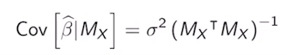
- σ²：大自然雜訊 epsilon 的方差。大自然干擾愈大，估算出來的 hat{β} 波動就愈劇烈。
- (X^{T} X)⁻¹：資料的結構。
- 大自然的雜訊 σ² 和我們的數據結構(X^{T} X)⁻¹ 會決定了我們估計的精準度
💡 矩陣對角線的秘密
Covariance Matrix的定義：它的第 i 列第 j 欄（ij entry）是 E[(Xi - µi)(Xj - µj)]
- 如果我們看對角線（Diagonal elements），也就是 i = j 的位置，公式就會變成 E[(Xi - µi)²] ── 這剛好就是方差（Variance）的定義！
- 因此，σ²(X^{T} X)⁻¹ 這個矩陣的對角線元素，分別就是截距項的方差 var(hat(β0)) 和斜率的方差 Var(hat{β1})。
在單變數（p=1）的情況下，展開的對角線可以得到兩個經典的方差公式：
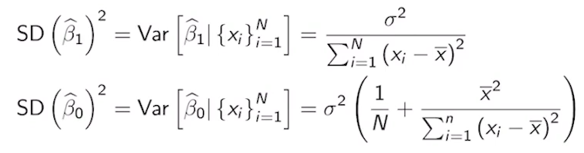

推導:

我們用一個統計學常用的精簡符號（離均差平方和）來簡化它： 記 Sxx = Σ_ (xi - bar{x})²
- Σxi = N bar(x)
- Σ(xi)² = Sxx + N (bar(x))²
代回X^{T} X 求反矩陣(X^{T} X)⁻¹
乘上 σ² 並提取對角線元素
- 矩陣右下角的位置（第 2 列第 2 欄），就是 hat{β1}（斜率）的方差。
- 矩陣左上角的位置（第 1 列第 1 欄），就是 hat{β0}（截距）的方差。

觀察 Var(hat{β1} 的公式：如果資料的點分散得越開（分母 Σ (xi - bar{x})² 越大），我們算出來的斜率就會越穩定、方差越小！
- 對於斜率 hat{β1} 的方差：
  - 分母是 Σ(xi - bar{x})²。這代表如果你的 x 數據點在 x 軸上散得愈開，分母就愈大，斜率的方差就愈小（估算愈精準）。這在幾何上很好理解：如果所有點都擠在很窄的範圍內，隨機雜訊一抖，直線的翹翹板效應就會很劇烈、斜率很不穩定；如果點拉得很開，直線的方向就很難被撼動。
- 對於截距 hat{β0} 的方差：
  - 它的公式多了一項 bar{x}^2。這代表如果你的數據中心點 bar{x} 距離原點（x=0）非常遠，截距的方差就會暴增。在幾何上，因為截距是直線通過 x=0 時的 y 軸交點。如果你的資料都在大老遠的地方（例如 x 在 100 附近），只要斜率有一點點小小的波動，這條線畫回 x=0 的地方時，產生的誤差就會被放大得非常誇張。

3. 思想實驗：1,000 次抽樣與常態分佈（直方圖）
為了證實上述理論，教授做了一個在真實世界中辦不到、但在電腦模擬中很常見的「思想實驗（Simulation）」：
- 模擬 1,000 個平行宇宙：假設大自然的真實斜率 β1 = 0.5。我們讓電腦模擬 1,000 組不同的訓練資料（每組包含 100 個樣本）。
- 計算 1,000 個斜率：每一組資料都用 Normal Equation 算一個 hat{β1}，我們一共得到 1,000 個不同的斜率數字。
- 畫成直方圖（Histogram）：這張直方圖呈現出非常漂亮的高斯分佈（Gaussian/Normal Distribution，鐘形曲線）：
- 中心點（Mean）：精準地停在 0.5 附近，這驗證了 不偏估計（Unbiased） 的理論。
- 標準差（Standard Deviation, SD）：寬度非常接近理論公式算出來的 0.05。
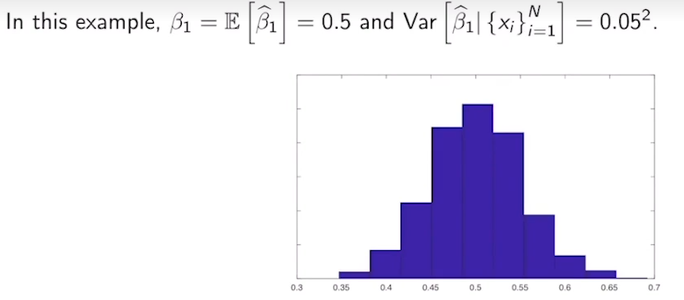
結論
這告訴我們，我們在現實生活中雖然只會拿到一組資料、算出一組 hat{β1} ，但只要這組資料的樣本數夠大，這個 hat{β1} 本質上就是從這個以真實值為中心的高斯分佈中「抽樣」出來的一個點。這為我們之後要做的假設檢定（Hypothesis Testing，例如 p-value 檢定斜率是否顯著）奠定了完美的數學基礎。

推導hat{β}的協方差矩陣公式

這段推導一眼看出為什麼大自然的雜訊 σ² 和我們的數據結構(X^{T} X)⁻¹ 會決定了我們估計的精準度。
(1) Var(aY) = a² Var(Y)
在矩陣（線性代數）的世界裡，如果 A 是一個常數矩陣（非隨機），y 是一個隨機向量，那麼這個常數提得出來，但因為矩陣有前後順序的限制，平方項會變成左乘自己、右乘自己的轉置： Var(AY) = A∙ Var(Y)∙A^{T}

(2) Var(hat{β} |Mx)
我們的前提是給定資料矩陣 Mx（意即當作已知的常數矩陣）。
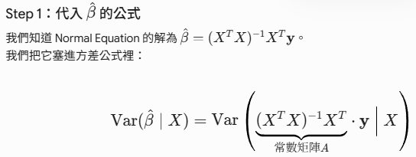
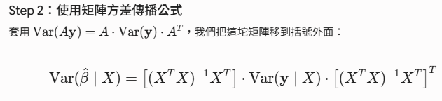
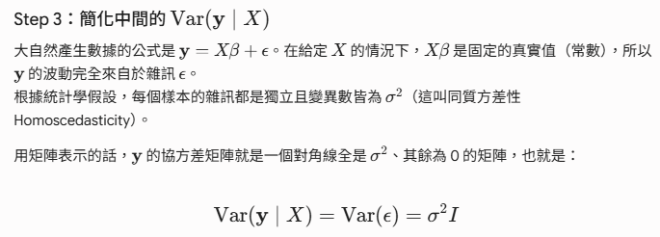
- 主對角線（Diagonal）：代表每個資料點「自己與自己」的方差（Variance）。
- 非對角線（Off-diagonal）：代表「不同資料點之間」的協方差（Covariance），用來衡量兩筆不同的資料是否會互相干擾、互相影響。
- 在古典線性迴歸中，我們假設大自然的雜訊 epsilon 滿足兩個條件（這也是投影片一開始提到資料是 independently（獨立） 抽樣出來的原因）
  - 假設一：獨立性（Independence 非對角線為 0）
  - 假設二：同質方差性（Homoscedasticity 對角線數值相同）

- 如果非對角線「不是 0」會怎麼樣？在某些真實場景中（例如時間序列資料，今天的房價往往跟昨天的房價有關），資料點之間並不獨立，這叫做自相關性（Autocorrelation）。 這時候，非對角線的位置就會出現非 0 的數字。如果遇到這種情況，傳統的常規方程（OLS）就會失效，統計學家就必須改用更進階的一般化最小二乘法（Generalized Least Squares, GLS）來處理那個沒有變成 0 的複雜矩陣了。

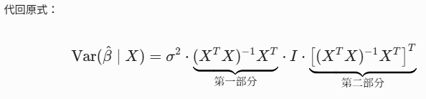
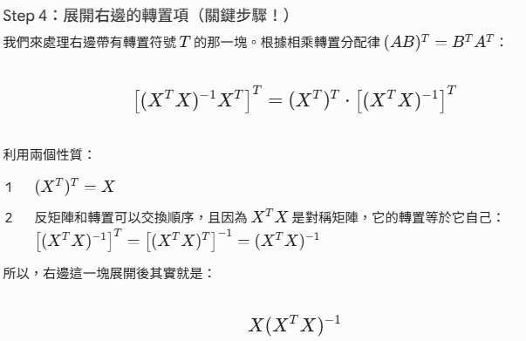
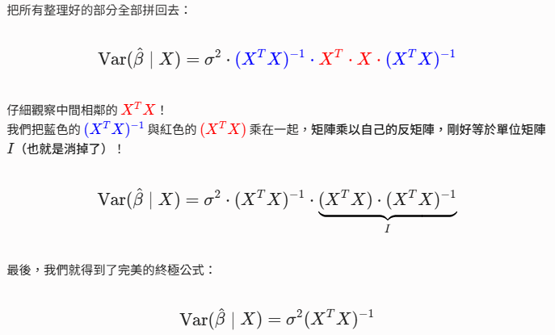
▶️ Confidence Interval (5:36)
To start this video, I'm going to recap an observation about the estimate beta1 hat.
In particular, if you remember by plotting a histogram for 1,000 different realizations of beta1 hat, for the 1,000 different data sets, we get a histogram that takes this form. This is very close to a normal distribution center around 0.5. In particular, one can theoretically prove that the PDF of beta1 hat is approximately a normal distribution.
We also know theoretically, that the expectation of beta1 hat is equal to beta1. So we know exactly the centre of that bell. And also we have expressions for the variance of beta1 hat given data. So given all these ingredients, we have a full theoretical characterization of the distribution of beta1 hat. Even though we will never be able to exactly retrieve the value of beta1 that Nature is using to generate the data that we observe, we can build confidence intervals based on data following the steps below.
The first observation is that 95% of the probability mass of a generic normal distribution with mean mu and variance sigma squared is in the interval mu- 2 sigma. In other words, if we take the bell shape of a normal distribution, center at mu and with the standard deviation sigma. If we look at the interval mu + - 2 sigma, meaning mu + 2 sigma, mu- 2 sigma, the area of the PDF under that curve is going to be equal to 0.95. Indicating that with a 95% probability, the random variable will live in the segment at the bottom.
Applying this fact to our random variable beta1 hat, we can say that beta1 hat will be in the interval, beta1 +- 2 standard deviations with a probability 95%. We can rewrite this event contained in the bracket using this sequence of inequalities. Essentially, beta1 hat will be sandwiched between beta1- 2 standard deviations and beta1 + 2 standard deviations.
You can prove yourself through a simple exercise that we can rewrite these two inequalities using these other two inequalities. So notice that the element in the middle is not beta1 hat anymore is beta1, which is the real value that nature is using to generate the data, and it's completely unknown to us.
Now in the next slide, we're going to rewrite the sequence of inequalities back in the form of an interval and we will plug it into a probability.
So this is what we have in this slide essentially, the probability that beta1 is sandwiched in the interval beta1 hat +- 2 standard deviations is equal to 95%. So this may sound very familiar, but notice that in the previous slide, the hat was in here, and we didn't have hat in here. But now this is the expression that we have and it's really important that we have flipped this hat. In particular, what this expression is telling us is that we have a 95% probability, the value that Nature is using to generate the data is in this given interval. Also remember that we can compute both beta1 hat, and it's a standard deviation used in a training data set, using the expressions at the bottom. Essentially, these are two expressions that we have previously derived. And now plugging those values into the expression on top, we will be able to have an explicit interval and we will know that beta1 will be in that interval with a 95% probability. So this is what's called the 95% confidence interval of beta1. We can use identical logic to compute the confidence intervals for beta0. Essentially, we can just use the expressions for the mean and the variance of beta0 and conclude that beta0 is going to be in the interval beta0 +- 2 standard deviation of beta0 hat with a 95% probability. It's worth to include a warning here to remember the assumptions we have made to reach these conclusions. The first assumption is based on our observation from the histogram, essentially we assumed that beta1 hat is normally distributed.
This is only approximately true in certain situations. However, in all the situation, this is not the case and you should be very aware that for certain problems, that does not apply. The second warning is that we have assume that we have access to the value of sigma squared, the variance of the measurement noise. This is not always true in practice, even though we'll see later on that there are practical ways to estimate sigma square
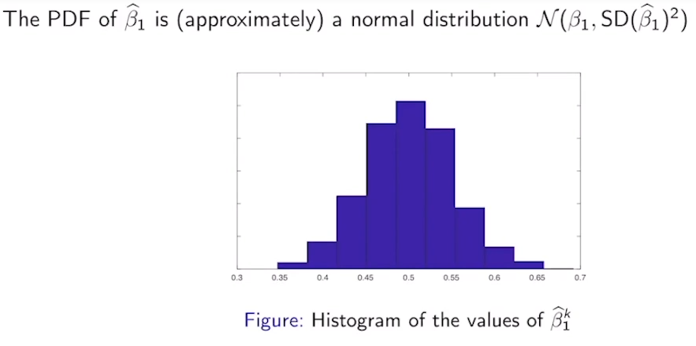
這段進入統計推論（Statistical Inference）非常經典的章節：如何幫線性迴歸的係數建立「95% 信心區間（Confidence Interval）」。
公式中「帽子（hat{}）」挪來挪去、還有不等式的方向搞得頭很暈。教授在這裡解釋得非常漂亮，他展現了如何把大自然未知的值，鎖在我們用資料算出來的區間裡。
我們一樣用四個核心步驟來徹底搞懂它：
1. 核心基礎：高斯分佈的「常態法則」
首先回顧高斯分佈的一個黃金比例：
對於任何一個常態分佈，有 95% 的機率質量（Probability Mass） 會落在**「平均值 ±2 倍標準差」** 的範圍內。
用數學式表達：如果一個隨機變數 X ~ N(µ, ε²)，那麼：P(µ - 2σ ≤ X ≤ µ + 2σ) = 0.95

2. 把法則套用到 hat{β1}（帽子在裡面）
因為我們前面證實了 hat{β1}也是個常態分佈，而且：
- 它的平均值（中心）是真實的 β1（大自然的秘密）。
- 它的標準差是 SD(hat{β1})
我們直接套用上面的黃金比例，把 hat{β1} 當成那個隨機變數 X：
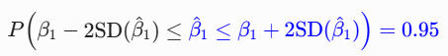
- 白話翻譯：我們有 95% 的把握，我們算出來的估計值 hat{β1}，跟真實核心 β1 的距離不會超過 2 倍標準差。
3. 關鍵移項：把帽子移到外面（Flipping the Hat）
雖然上面的式子很完美，但在現實生活中毫無用處。為什麼？因為大自然的 β1 是未知的，我們根本沒辦法把 β1 ± 2{SD} 的區間算出來。
所以，教授做了一個關鍵的不等式移項, 我們把中間的夾擊不等式拆開來看：
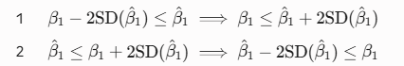
把這兩個新移項後的不等式重新拼回去，把大自然未知的 β1 留在中間：
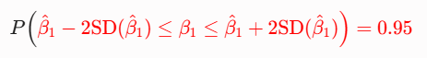
💡 結構的重大轉變！
注意到帽子的位置了嗎？
- 之前：區間端點是固定的（未知真實值），中間夾著一個會隨機波動的估計值 hat{β1}。
- 現在：中間夾著一個大自然賜予、動彈不得的神秘數字 β1；而兩旁的區間端點則變成了由我們親手用資料算出來的數字！
這個用資料算出來的隨機區間(CI, confidence interval)：
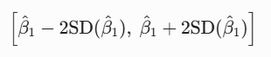
就叫做 β1 的 95% 信心區間：雖然我們永遠不知道真實的 β1 是多少，但透過我們手上的這份資料，我們可以畫出一個範圍，並宣告「大自然的真實值有 95% 的機率被我這個區間給逮到！」
同樣的邏輯也可以完全套用到截距項 β0 的信心區間。[hat{β0} ± 2SD(hat{β0})]
4. 兩個重要警告 (Warnings)
在統計學中，所有的完美結論都建立在嚴格的假設上。實務上這套理論有兩個潛在的盲點：
警告一：常態性假設（Normality Assumption）
我們能用「± 2 倍標準差 = 95%」，是因為我們假設了 hat{β1} 完美服從常態分佈。
- 在大樣本（中央極限定理作用下）或大自然雜訊本身就是高斯分佈時，這很精準。
- 但如果你的資料量很少，或者大自然的雜訊非常怪異（例如嚴重偏態、有極端值），hat{β1} 的分佈就不會是常態分佈，這時候「乘以 2」的規則就會失效。
警告二：未知的 σ²（Unknown Noise Variance）
上一題我們推導的標準差公式：
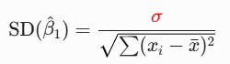
要算出這個標準差，我們必須知道大自然的雜訊大小 σ。但在現實中，大自然連 β 都不告訴你了，怎麼可能告訴你 σ？
- 後續伏筆：實務上我們無法直接拿到 σ²。我們通常會用殘差（Residuals）去估算一個 (hat{σ})²
- 連帶影響：當你用估計的 (hat{σ})² 取代真實的 σ² 時，因為引入了新的不確定性，原本的常態分佈（Z 分佈）就會降級成 t-distribution。這時候要達到 95% 的信心，乘數就不再是精準的 2（或 1.96），而是要根據樣本數去查 t 分配表（通常會比 2 再大一點點）。
💡 觀念思考
了解了「翻轉帽子」的過程後，你可以試著回答這個經典的統計面試題：
「95% 信心區間」代表的是「真實的 β1 有 95% 的機率落在這個區間內」嗎？
- 嚴格的統計學答案是：不是。 因為當你把特定的數據代入公式、算出了具體的數字（例如區間是 [0.4, 0.6]）之後，真實的 β1（比如 0.5）要嘛在裡面（機率 100%），要嘛不在裡面（機率 0%），它不是隨機的。
- 正確的理解是：這個「95%」是指這個製造區間的方法。如果我們重複做 100 次實驗、畫出 100 個不同的信心區間，大約會有 95 個區間會成功包含真實的 β1。

▶️ Hypothesis Testing (13:18)
Welcome back. In this set of slides, we're going to cover the topic of hypothesis testing. To motivate this topic, we're going to consider a data set d, drawn from a linear model with p =1. In particular, the output will be simply an intercept, plus the slope times an input, plus a measurement noise.
Looking at the data generated by this linear model, we would like to decide whether the input variable X1 influences the output variable Y. Whenever X1 does not influence Y, the term in this expression disappears. In other words, we can mathematically model that effect by setting beta 1 = to see them. As a result, the output Y be simply a constant plus some measurement noise. To figure out the effects one influences the output, one might be tempted to estimate the value of beta 1 hat, and check if this value is equal to 0. However, this is not a good idea for the following reason. Whenever beta 1 is equal to 0, we know that beta 1 hat is a normal distribution centered around 0. Therefore, the probability that beta 1 hat is exactly 0 is going to be 0.
If you don't see this, you can convince yourself of this fact by looking at, for example, the Gaussian distribution that can model weights in a population. So let's consider the weight of males in the population. This is a Gaussian distribution that's probably centered around, let's say, 80 kilos with some standard deviation. Now, if I ask you the question, what's the probability that the weight of a randomly pick individual is equal to an exact real value, maybe 82.371817. The probability of that event is going to be 0, because the randomly picked individual will have a 0 probability of having exactly this weight. However, you can ask questions like what is the probability that the individual weights between 78 and 79 kilos? And that probability will be the area above that segment. They say it will be a positive number. Motivated by this problem, we're going to state the following two hypothesis. The first hypothesis, called the null hypothesis, and denoted by h sub 0. It states that there is no relationship between X1 and Y. In other words, beta 1 = 0. We will consider an alternative hypothesis that we denote by h(a). That is states, that there is some relationship between the input X1, and the output Y, in other words, beta 1 is different than 0.
To analyze this hypothesis, we're going to look into the statistical properties of the random variable beta 1 hat. Consider that h0 true.
In other words, beta 1 = 0. In that case, we know that the random variable beta 1 hat would follow a normal distribution. Centered at 0, and with a standard deviation is the beta 1 squared, which is something that we computed before.
Therefore, with a 95% chance, beta 1 hat would be in the confidence interval, 0 plus minus twice a standard deviation. Essentially, this is something that we saw before, but it doesn't hurt to review it again. So if I have a normal distribution center at 0, and with a given standard deviation, I'm going to call it as D, the probability that beta 1 hat. The random variable with this PDF is in plus minus twice the standard deviation. We'd be given by the area on top of that interval, that as we saw before, is going to be equal to 95% of the probability mass.
In other words, even the variable beta 1 is not in this confidence interval. We have the strongest statistical evidence to reject the null hypothesis. This is in fact the case, because if the null hypothesis is true, the probability that beta 1 hat falls outside this interval is going to be 5%, which is a very small probability. Therefore, it's going to be unlikely that beta 1 hat falls outside the confidence interval when the null hypothesis is true.
Apart from using confidence intervals to verify hypothesis, we can pose alternative but equivalent tests.
The first one utilizes a random variable, t1, which is equal to beta 1 hat divided by its standard deviation. Therefore, this random variable follows a normal distribution centered at 0 with a standard deviation equal to 1, when the null hypothesis is true.
To convince yourself of this fact, notice that when the null hypothesis is true, the expectation of beta 1 hat = 0. Also, the variance of t1 is going to be equal to the variance of beta 1 hat divided by the square of the standard deviation, which is the variance itself. So the result would be the deviation of the variance over the variance, which is equal to 1. As a conclusion, we would have a 95% chance that the variable t1 is in the confidence interval 0 plus minus twice the standard deviation. Which is equal to 1, meaning in the interval -2 to 2. Or equivalent, that the absolute value of t1 < = 2. In other words, if h0 is true, we have the t1 is a random variable centered at 0 with a standard deviation equal to 1. Therefore, 95% of the mass will be concentrated in the interval -2, 2, which can also be equivalently. It's stated as the absolute value of t1 < = 2. In consequence, if the absolute value of t1 > 2, meaning our random variable t1 is in the tail of this normal distribution, then we have a strong statistical evidence to claim that h0 is unlikely to be true. This is exactly what we had before. Meaning, if h0 is true, it's most likely that t1 will fall in this confidence interval. And an observation outside the confidence interval would be a red event. Again, that doesn't mean that it's impossible. That's why we claim that we have a strong statistical evidence, and we don't make definite claims about the influence of X1 on Y.
To validate our results, we're going to consider that the following numerical illustration. We're going to consider a linear model with p = 1, in which the input X1 does not influence the output. In other words, the value of beta 1 in our model is equal to 0. We'll assume that the inputs are generated according to our normal distribution, and that the measurement noise has a variance equal to 1.
We can generate 1,000 different data sets using the model above and compute for each one of these data sets the value of D1k. The histogram below shows the distribution of t1k for the 1,000 realizations under consideration, which approximately follows a normal distribution centered at 0 with variance 1, which is what we claim in the previous slide.
Therefore, if the corresponding value of t1 is not in the range -2,2, we have strong statistical evidence to reject the null hypothesis that beta 1 = 0. You can observe in this histogram that beta 1 hat lying outside that interval is a rare event. Although, it could happen every now and then.
To fully understand the kind of things that we can claim using hypothesis testing, I have prepared this legal comparison. I'm calling a legal parable.
I'm going to read through this text, with the hope that you can follow my logic. Essentially, let's consider a person A that is on trial for murdering person B.
Before the trial, the prosecutor collects evidence to prove whether A has in fact the murderer of person B.
In the legal system of many countries, including the US, a person is considered Innocent until proven guilty.
Consequently, our null hypothesis h0 is going to be that a is innocent.
The alternative hypothesis, Ha, is that A is guilty. We're going to now consider a few situations. If the prosecutor is able to collect a strong statistical evidence to convince the jury that he is guilty, meaning the null hypothesis is rejected, there is always a chance that he is innocent, but convicted unfairly.
Similarly, in our problem, whenever you reject the null hypothesis using a statistical test, there is always a chance that h0 is true. Since our claim is based on statistical evidence, not on direct observation of the ground truth, which is something that you can never do.
We can also consider another situation which is, if the prosecutor is not able to convince the jury to declare A not guilty, meaning the null hypothesis is not rejected. That does not imply that he is innocent.
Similarly, you can never prove that the null hypothesis is true using statistical evidence. In other words, failing to reject the null hypothesis does not imply accepting it.
However, in practice, when a person is declared not guilty, the legal system acts as if the person is innocent. Similarly, in statistics, whenever we fail to reject the null hypothesis, it is common to act as if the null hypothesis is true.
So I invite you to read this carefully. And I hope this somehow clarifies some of the conclusions you can make using hypothesis tests.
Let's move on to assessing model accuracy.
We're going to define some metrics that are useful to assess model accuracy. The first one is the residual sum of squares that we know from before. Essentially, the residual sum of squares are the sum of the squares of the difference between the actual output of a point i, and the predicted output that you make using your model.
Remember that in your model, you use beta 0 hat and beta 1 hat, meaning the parameters estimated from the training data set.
We also have another metric called the total sum of squares. So this metric measures some of the differences between the actual output of a point, and the empirical average of all the points yi.
Notice that it took a sum of the squares corresponds to the sum of the squares of the errors when your model has some beta 1 = 0. In other words, when the input does not influence the output,
we also have two more ways to measure the quality of a model.
The third one is R square. So R square is define using the following fraction. So in the numerator, we'll have the total sum of squares minus the residual sum of squares, normalized by the total sum of squares. Through simple algebra, you can reach to the conclusion that this is equal to 1- the division between RSS and TSS.
Notice that the R square measures the relative reduction in the squared error before and after to include X1 has an input variable. To understand this claim, notice that TSS measures the squared error when we do not include X1 in our regression. While the RSS measures the squared error when X1 is considered in our regression. Finally, we define the Residual Standard Error, denoted as RSE, as the square root of the RSS divided by N- p- 1. Where N is the number of points in our data set, p is the number of entries in our input vector.
And in practice, the RSS is useful to estimate the standard deviation of the measurement noise. So whenever the standard deviation is not available, you can use the RSE, which is something that you can compute from a given dataset.
1 Attempt Quiz: Hypothesis Testing

這段正式進入機器學習與統計學中極度核心的兩個領域：
假設檢定（Hypothesis Testing） 以及 模型準確度評估（Model Accuracy Metrics）。
我們把這段長文拆解為三大核心區塊：
1. 為什麼不能直接看 hat{β1} 是否等於 0？
在單變數模型 Y = β0 + β1 ∙X1 + ε 中，如果想知道 X1 對 Y 有沒有影響，直覺上就是去看大自然的真實斜率 β1 是否為 0。
- 如果 β1 = 0，代表 X1 根本影響不了 Y
那為什麼我們不能直接算出一組 hat{β1}，然後檢查它是不是剛好等於 0 呢？
💡 教授的精闢解釋：因為 hat{β1}是一個連續型隨機變數（服從常態分佈）。在機率論中，連續型分佈要「精準砸中某一個孤立實數點」的機率是 0。
- 舉例：平均體重是 80 公斤。如果我隨機抽查一個人，他體重「剛好完美等於 82.371817... 公斤」的機率是 0。但如果問他體重落在 78 到 79 公記之間的機率，這就是一個大於 0 的面積。
- 結論：就算大自然真正的 β1 確實是 0，你用資料算出來的 hat{β1}也幾乎必定會是 0.02、-0.05 這種帶有雜訊的小數，它永遠不可能精確等於 0。因此，我們需要一套「容許誤差波動」的遊戲規則 ── 這就是假設檢定。
2. 虛無假設 vs. 對立假設 與 t 檢定
為了進行科學判斷，我們設定兩個互相對立的假設：
- 虛無假設（Null Hypothesis, H0）：β1 = 0（代表 X1 與 Y 沒有關係，這是我們要去質疑、試圖推翻的現狀）。
- 對立假設（Alternative Hypothesis, Ha）：β1 ≠ 0（代表 X1 與 Y 有關係）。

檢定方法1:
如果 H0 是真的（β1 = 0），
r.v. hat{β1}會服從常態分布 N(0, SD(hat{β1})²), 95%機率. hat{β1}會落在±2倍SD(hat{β1})區間內
如果不在區間內 就有強烈的統計證據去reject H0假設 (因為超出CI區間是5%小概率事件)

檢定方法2: 建立 t 統計量（t-statistic）
為了方便判斷，我們把估計值標準化，定義一個新變數 t1：
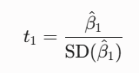
那麼這個 t1 就會服從中心為 0、標準差為 1 的標準常態分佈N(0,1)
根據常態分佈的「±2 倍標準差法則」：
- 如果 H0 為真， t1 有 95% 的機率會乖乖待在 [-2, 2] 這個區間之內。
- 決策準則：如果你用手邊的資料算出來的 |t1| > 2（落在極端的兩側尾巴），這在 H0 為真的世界裡是一個發生機率小於 5% 的「罕見事件」。此時，我們就有強烈的統計證據來拒絕虛無假設（Reject H0），改為相信 Ha（也就是 X1 確實對 Y 有顯著影響）。

⚖️ 教授的法庭比喻（超級重要！）
這段法律類比完美詮釋了統計學的保守主義：
法律審判 (Legal System) | 統計檢定 (Hypothesis Testing)
無罪推定（審判前假設被告無罪） | 虛無假設 H0（預設變數之間沒有關係）
檢察官提出強力證據控告被告 | 計算出極端的t 統計量
宣判有罪（推翻無罪推定） | 拒絕 H0（宣稱變數有顯著影響）
誤判（把無辜的人判有罪） | 型一錯誤 (Type I Error)（大自然明明沒關係，你卻說有）
證據不足，宣判「無罪（Not Guilty）」 | 無法拒絕 H0 (Fail to Reject H0)
⚠️ 經典靈魂拷問：法庭宣判「Not Guilty（無罪）」，代表被告真的百分之百沒殺人嗎？
答案是：不知道，只是目前的證據不足以定罪他。
同理，在統計學中，「無法拒絕 H0」絕對不等於「證明了 H0 是真的」。我們只是說「手頭的證據還不夠把現狀推翻」而已。但在實務上，我們會暫時表現得好像 H0 是真的一樣。

3. 評估模型好壞的三大統計指標
當我們確認了特徵有效後，接下來要評估這個模型到底預測得準不準。投影片介紹了三個核心指標：
A. 總平方和 (Total Sum of Squares, TSS)
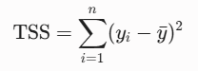
- 物理意義：這是「最爛、最瞎的模型」所產生的誤差總量。輸入特徵 X1不影響Y（相當於強迫 β1 = 0），Y= β0+ε, 那你對每筆資料的預測就只能無腦地猜輸出值的平均數 bar{y}。TSS 代表這組資料天生自帶的總波動量。
B. 殘差平方和 (Residual Sum of Squares, RSS)
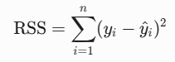
- 物理意義：這是「引入特徵 X1 建模後」依然無法被模型解釋、殘留下來的誤差。
C. 決定係數 (R² Score)
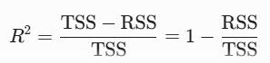
- 物理意義：代表你的模型幫忙消除了多少比例的誤差，其值介於 0 到 1 之間。
- 舉例：如果 R^2 = 0.80，代表大自然資料總波動（TSS）中有 80% 成功被你的特徵 X1 解釋並抓到了，只剩下 20% 是無法解釋的殘餘雜訊。R^2 愈接近 1 越好。
D. 殘差標準誤 (Residual Standard Error, RSE)
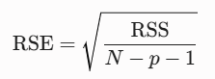
- 物理意義：這用來估算我們上一章極度渴望知道的大自然測量雜訊標準差 σ。
- (RSE)² 是大自然雜訊σ² 的不偏估計量
- 它是對殘差平方和進行平均（分母是自由度 N-p-1）再開根號。RSE 的數值越小，代表模型預測的絕對誤差範圍越小。
- 分母的 N-p-1 代表的是殘差的自由度（Degrees of Freedom）。之所以要多減一個 1，是因為「截距項（Intercept, β0）」的存在。

💡 觀念統整
- 想要確認特徵有沒有用？看 t 檢定（或 p-value）。
- 想要看模型解釋資料的能力（相對好壞）？看 R^2。
- 想要知道模型預測時平均會漏掉多少實際單位（絕對誤差）？看 RSE。
----
為何用t statistic
- 在理論推導時，我們確實常常看到「如果 H0 為真，標準化後會服從標準常態分佈（即 Z 分佈）」。那為什麼在實務上（如 R、Python），這裡都統一叫做 t-statistic，而不是 Z統計量呢？
- 最核心的原因在於：「我們無法得知大自然真正的雜訊方差 σ²。」
Z統計量:
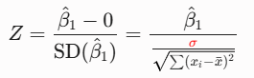
注意到分母那個紅色的 σ 了嗎？那是大自然真正的雜訊標準差。
既然拿不到真實的 σ，統計學家想到的辦法就是「用手邊的資料來估算一個 hat{σ} 吧！」。
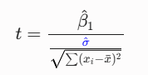
關鍵代價：常態分佈（Z）降級為 t 分佈
這兩種統計量看似只差在一個帽子（σ 變 $hat{σ}），但在數學分佈上卻產生了本質上的改變：
- Z 統計量：分子 hat{β1} 是隨機變數，分母的 σ 是固定的常數。一個常態分佈除以一個常數，結果依然是完美的常態分佈（Z 分佈）。
- t 統計量：分子 hat{β1} 是隨機變數，而分母的 hat{σ} 是用資料算出來的，所以分母也是一個隨機變數！當一個常態分佈的隨機變數，除以另一個隨機變數（本質上跟卡方分佈相關）時，它的波動會被顯著放大。這種「隨機變數除以隨機變數」所推導出來的新分佈，就是著名的 Student's $t$-distribution
t 分佈與 Z 分佈的幾何差異
如果把 t 分佈與標準常態分佈（Z）畫在一起，你會發現：
- t 分佈的形狀雖然也是鐘形，但是頂峰比較矮，兩側的尾巴比較肥厚（Fat tails）。
- 肥尾的統計學意義：因為我們是用估計的 hat{σ}，我們引入了「額外的不確定性」。肥尾代表在 t 的世界裡，踩到極端誤差的機率比 Z 還要高。
- 實務上：只要資料量夠大（N 夠大），不論你叫它 t 還是 Z，判斷的邊界都大約在±2 附近（更精確地說是 1.96）。

4. Python Lab
▶️ Exploratory Data Analysis (7:50)
Hello everybody, welcome to recitation two, we're going to be going over exploratory data analysis. The goals for this recitation are to familiarize yourself with the data, summarized features of particular importance. Establish a relationship between features, conduct, featured transforms and go through a couple of examples.
So to familiarize yourself with the data we now want to understand the units of our data, add a missing values, not a number, nulls. The format of our features. Their continuous variables, categorical or any unusual feature format like text or a geospatial location coordinate.
We're also going to see how to do summary statistics and conduct a histogram.
So to visualize the relationship between features. We can use the following types of plots for the following types of situations for dependent and independent variables. In this course, we're going to focus on a histogram and scatter plot for the most part.
We talked about featured transforms. We mean introducing new features either from external data sources or using the existing features we were given to create new features. This is important for obtaining better insights and better predictions.
Here you'll see the libraries you want to use for this, NumPy as good for math operations and a data type called an array which is similar to Python's builtin list. Pandas is good for reading in the data, manipulating the data.
That's going to be our main library that we use. Matplotlib is good for plotting data and so is Seaborn.
So for this first example, we're using the college data set. These are the features and these are the descriptions.
To read in our data we use Pandas.read CSV. We can rename are columns with it by passing a dictionary. And this is what the preview looks like.
Using data.describe, we can obtain the following summary for our data set. We see that the count for every feature is 777, which is a number of entries that are missing, so this is a clean data set.
And an interesting find is that there are schools with graduation rates greater than 100%, so something you're going to have to think about is what do we do with these schools? Should we just ignore them?
And we can use data.info to get information about variable names.
A cool thing you can do with the Pandas data frame is you can pass in a boolean to the bracket operator where you specify if you want a specific column to have a specific variable.
So to return the entry where the names column is University of Pennsylvania, we do it like in a cell 6, and this is what we get.
So now we're going to show how to visualize their data with Matplotlib.
So to create a histogram, we simply pass in a vector of value such as graduation rating, we specify the number of bins. And then we specify our X label and we get the following plot.
So fig will specify a figure object that we're going to perform manipulations on. So all following plot calls will operate on this figure object in total and create a new figure object. Plt.subplot can specify the dimensions of your plots and which plot you want to manipulate specifically. So plt.subplot 221 says there's going to be two rows and two columns of plots, and we want the following lines to operate on the first subplot. We create a histogram of SF ratio and set the color and title. Then we do similarly with the second, third and fourth subplots, and this obtains the following images.
Two ply featured transform. We're going to copy your data first. We need to use .copy to make sure that any changes we make to data two will not make changes to data one or data which was in our original variable. And we can define a new column accept rate by just operating on the old columns like so.
Here we see two examples of creating bar plots. The first is to use Pandas' group by function, which groups entries by the different values a specific column can take. This example we pass in private as a column name, so it will group the entries by whether or not the entry is private or not. By calling .size we get the count for each group.
And we can obtain a bar plot by just calling count.plot.bar.
The second way is to use the Seaborn Library, which imported as SNS and calling sns.countplot on the private column of the data frame.
Now to see the relationship between two specific dependent variables. We can use a scatter plot. And we simply pass in the X column for the X argument and the Y column for the Y argument.
And here we can see the relationship between acceptance rate and graduation rate.
We can also use Seaborn to create a box plot like this, where if you pass in two arguments, the first argument will be interpreted as the X axis. It will have to be a categorical variable. Said it can create one box plot for each possible value that categorical variable.
And here we see an example of exploring the relationship between the dependent variable's top 10%, top 25%. With the dependent variable graduation rate. To do this, we create two scatter plots.
Both of graduation rate and the Y axis and top 10%, top 25% in the X axis.
We see that there is clearly an increase in relationship between top students and graduation rate.
With this, we conclude the third week of the course. In this week we have a started our coverage on linear regression. I strongly suggest that you go to Chapter three of this book, an introduction to statistical learning, and read through sections 3.1 and 3.2. Next week, we'll continue our coverage of linear regression. I'll see you next week.

Lab 2 Materials
這段教材從理論的數學推導，帶入實務上機器學習與資料科學的第一步：探索性資料分析（Exploratory Data Analysis, EDA）。
在實際動手建立線性迴歸模型之前，我們必須先「認識資料」，了解資料的分布、特徵之間的關係，並進行特徵轉換。以下為你將這段 EDA 的實作課程拆解為四大核心精華：
1. 認識資料的第一步：基本健檢
拿到資料集（例如這裡使用的美國大學資料集 college.csv）後，不能盲目直接建模，必須先執行以下兩個 Pandas 的黃金指令：
- data.info()：查看資料的骨架。它會告訴你有哪些欄位（特徵）、總共有幾筆資料、以及每個欄位的資料型態（Data Type） ── 是連續型的數值（float64, int64）、還是類別型的標籤（categorical / object），或是文字、地理座標等特殊格式。
- data.describe()：輸出自動化的敘述性統計摘要（Summary Statistics），包括每欄的平均值（Mean）、標準差（Std）、最大值（Max）、最小值（Min）與四分位數。
💡 實務上的魔鬼細節
教材中提到一個非常經典的實務案例：透過 data.describe() 發現所有特徵的計數（Count）都是 777，剛好等於總資料量，代表這是一份沒有缺失值（Missing Values / Null / NaN）的乾淨資料。
但緊接著發現了一個異常現象：居然有學校的畢業率（Graduation Rate）大於 100%！
資料科學家的思考：這就是真實資料的常態。遇到這種狀況，你需要思考商業邏輯（Business Logic）：是資料登錄錯誤？還是因為某些學生延畢、跨年級計算導致分式分子大於分母？在實務上，我們可能需要將大於 100% 的值強制截斷（Clip）為 100%，或視為異常值（Outlier）進行處理。
2. 核心視覺化工具：單變數與雙變數分析
在 EDA 中，我們主要依賴 Matplotlib 與 Seaborn 這兩個繪圖庫來觀察特徵分布與特徵間的關聯。
A. 單變數分布：直方圖（Histogram）
用來觀察「單一連續變數」的數據分布形狀。例如：
Python
plt.hist(data['Grad.Rate'], bins=20)
教材中還示範了實務上很常用的 子圖（Subplots） 配置：plt.subplot(221)。
- 這裡的 221 代表：建立一個 2 x 2 的網格（共 4 格），接下來的繪圖指令將操作在第 1 格（左上角）。依此類推 222（右上）、223（左下）、224（右下），讓你能在一個畫布上同時對照多個特徵的分布。
B. 類別變數統計：條形圖（Bar Plot / Count Plot）
用來統計類別變數（例如：公立或私立學校 Private）的各類別數量。
- Pandas 作法：先用 .groupby('Private').size() 算出各組數量，再串接 .plot.bar()。
- Seaborn 作法：直接呼叫 sns.countplot(x='Private', data=data)，語法更直觀。
C. 雙變數關係：散佈圖（Scatter Plot）
用來觀察兩個連續變數之間是否存在線性關係。這對於後續要建立線性迴歸模型至關重要！
- 教材中展示了「錄取率（Acceptance Rate）與畢業率」以及「前 10% 優秀高中生比例與畢業率」的散佈圖。
- 幾何結論：散佈圖清楚顯示，頂尖高中生比例越高的學校，畢業率有明顯的上升趨勢。這代表該特徵與目標變數之間存在正相關，是非常適合放入線性迴歸模型的強大特徵。
3. 關鍵操作：特徵轉換（Feature Transforms）
有時候，原始資料給的特徵並不直接適合建模，我們需要將現有特徵進行數學組合，創造出更能提供洞察力的新特徵。
⚠️ 一個極度重要的程式碼陷阱：.copy()
教材中特別強調，在做特徵轉換前，如果要複製一份 DataFrame，絕對要使用 .copy()：
Python
data2 = data.copy()
如果你寫成 data2 = data，這在 Python 中只是建立一個「指針（Pointer）/ 引用」。當你對 data2 進行修改時，原本的 data 也會跟著被竄改。使用 .copy() 才能確保在記憶體中開闢一塊完全獨立的新空間（Deep Copy）。
特徵衍生範例
利用原始的「申請人數（Apps）」與「錄取人數（Accept()）」相除，衍生出全新的核心特徵 ── 錄取率（Accept Rate）：
Python
data2['accept_rate'] = data2['Accept'] / data2['Apps']
4. 統計推論的基石：箱線圖（Box Plot）
教材最後示範了如何利用 Seaborn 繪製箱線圖：
Python
sns.boxplot(x='Private', y='Grad.Rate', data=data)
箱線圖的 X 軸通常傳入類別變數（如是否為私立學校），Y 軸為連續變數（如畢業率）。它能幫我們一眼看出兩組資料的統計分布差異（包含中位數、四分位距以及是否有極端離群值）。

🗺️ 學習地圖總結與下一步
這週的課程幫你把實務 EDA 的工具鏈串接了起來：
Matplotlib/Seaborn (分布與關係視覺化)} \longrightarrow \text{特徵工程 (衍生新欄位)}$$
教授在最後強力推薦大家閱讀機器學習聖經 An Introduction to Statistical Learning (ISL) 的第 3.1 與 3.2 節。這本書能幫你將前幾堂課學到的 Normal Equation、斜率方差、t 檢定，與這一章看到的特徵分布完美融會貫通。

